**Practical No: 08**

**Aim: Implementing ensemble Learning Algorithm and Support Vector Machine(SVM) Algorithm**

**1. Ensemble Learning**

import numpy as np

from sklearn import datasets

from sklearn import model_selection

from sklearn.ensemble import RandomForestClassifier

from sklearn.ensemble import VotingClassifier

from sklearn.linear_model import LogisticRegression

from sklearn.naive_bayes import GaussianNB

from sklearn.tree import DecisionTreeClassifier

warnings.simplefilter("ignore")

iris = datasets.load_iris()

x,y = iris.data,iris.target

labels = ["Random Forest","Logistic Regression","GaussianNB","Decision Tree"]

m1 = RandomForestClassifier(random_state=42)

m2 = LogisticRegression(random_state=1)

m3 = GaussianNB()

m4 = DecisionTreeClassifier()

for m,label in zip([m1,m2,m3,m4],labels):

scores = model_selection.cross_val_score(m,x,y,cv=5,scoring="accuracy")

print(f"Accuracy: {scores.mean()} {label}")

voting_clf_hard = VotingClassifier(estimators=[(labels[0],m1),(labels[1],m2),(labels[2],m3),(labels[3],m4)],voting='hard')

voting_clf_soft = VotingClassifier(estimators=[(labels[0],m1),(labels[1],m2),(labels[2],m3),(labels[3],m4)],voting='soft')

scores1 = model_selection.cross_val_score(voting_clf_hard,x,y,cv=5,scoring="accuracy")

scores2 = model_selection.cross_val_score(voting_clf_soft,x,y,cv=5,scoring="accuracy")

print(f"Accuracy of the hard voting: {scores1.mean()}")

print(f"Accuracy of the soft voting: {scores2.mean()}")

**Output:**

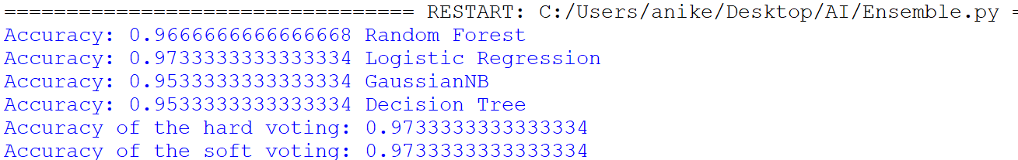

**2. Support Vector Machine**

import numpy as np

import matplotlib.pyplot as plt

from sklearn import datasets

from sklearn.svm import SVC

from sklearn.preprocessing import StandardScaler

from sklearn.model_selection import train_test_split

# Load the Iris dataset

iris = datasets.load_iris()

X = iris.data[:, :2] # Using only the first two features (sepal length and sepal width)

y = iris.target

# Split the data into training and testing sets

X_train, X_test, y_train, y_test = train_test_split(X, y, test_size=0.3, random_state=42)

# Standardize the features

scaler = StandardScaler()

X_train = scaler.fit_transform(X_train)

X_test = scaler.transform(X_test)

# Train the SVM model with a linear kernel

svm_model = SVC(kernel='linear')

svm_model.fit(X_train, y_train)

# Function to plot decision boundaries

def plot_decision_boundaries(X, y, model):

x_min, x_max = X[:, 0].min() - 1, X[:, 0].max() + 1

y_min, y_max = X[:, 1].min() - 1, X[:, 1].max() + 1

xx, yy = np.meshgrid(np.arange(x_min, x_max, 0.01), np.arange(y_min, y_max, 0.01))

Z = model.predict(np.c_[xx.ravel(), yy.ravel()])

Z = Z.reshape(xx.shape)

plt.contourf(xx, yy, Z, alpha=0.3)

plt.scatter(X[:, 0], X[:, 1], c=y, edgecolors='k', marker='o', s=100, cmap=plt.cm.Paired)

plt.xlabel('Sepal length (standardized)')

plt.ylabel('Sepal width (standardized)')

plt.title('SVM Decision Boundaries')

plt.show()

# Plot decision boundaries using the training set

plot_decision_boundaries(X_train, y_train, svm_model)

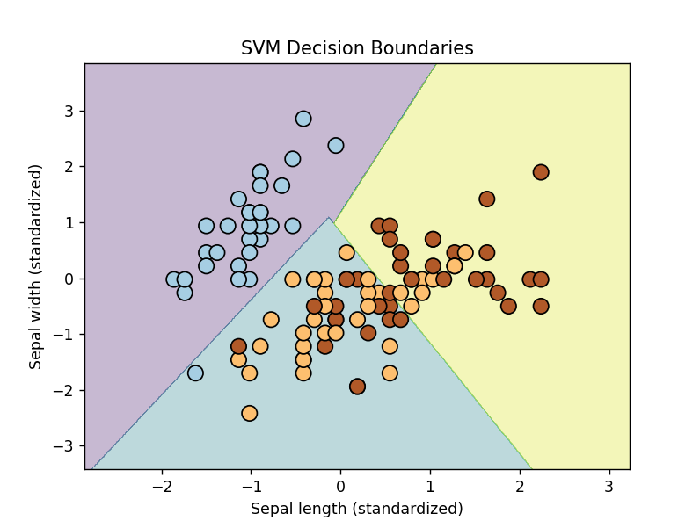**Output:**